Workshop 2: Loops and Decisions
In the last workshop we looked specifically at the idea of sequence and how getting our instructions in the right order allow us to create algorithms. The cognitive processes involved in creating algorithms are referred to as “computational thinking”.

“A rose by any other name”
One issue to consider when working with computers and especially writing code is that programmers are prone to use different words to describe the same concept.
One good example of this is the ideas we are going to introduce this week which are iteration and conditionals.
Iteration is sometimes referred to as repetition or, to boil it down to the simplest terms it refers to looping.
Conditionals are sometimes referred to as selection, or again to boil it down, if-statements or decisions.
It can be confusing and most programmers will switch usage without a second thought (including me) assuming that you will be able to keep up, so apologies in advance.

Looping
We have already hinted at the idea of looping last week in the toaster analogy.
Here it is just as a reminder...
Repetition takes place when we can’t complete a certain task in one cycle of activity.
Let’s assume we have a four slice toaster. If we are making four rounds of toast or less then we can complete the task in one go. If however we want to make eight slices of toast we must repeat the main task until all of the bread has been toasted.
The extended logic may look something like this...
- While there is bread to toast do the following
  - Slice bread
  - Insert bread into toaster
  - Turn on the toaster
  - If toast is burning then remove the bread
  - Butter toast
- Repeat the from the start if required
Looping commands are located under control under the scripts tab...
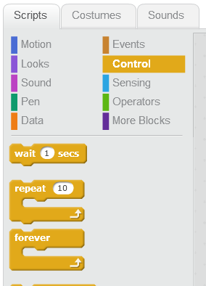

Decisions
As with loops we have already hinted at how decisions might play a part in making toast...
Selection relates to making changes to the normal sequence of activities if a certain set of conditions happen to be true.
Consider the following sequence for making toast...
- Slice bread
- Insert bread into toaster
- Turn on the toaster
- If toast is burning then remove the bread
- Butter toast
In this case we have added a conditional step which only takes place if the toast is burning.
Decision making instructions are also located under the control section just below the looping instructions...
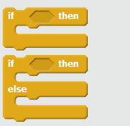
We are going to make use of these control functions to create a simple game.

Slug Racer

This game isn’t going to win any prizes for most interesting game in the world; however it does serve to illustrate how to perform various tasks in scratch.
The “game play” involves moving your mouse around the track, which the slug will follow. Should the slug hit the green sides of the white track then it makes a screeching noise. As the slug travels round the track it also leaves a trail (like all good slugs should!)

Importing the Slug Sprit
There is a sprite already created for you for download on the module shell. Save this file to your local computer and then import it to the sprites area of a new project using the folder icon indicated below.
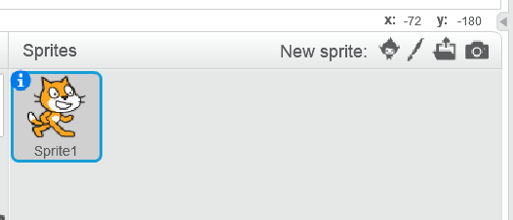
Once the slug is imported you will need to remove the Scratch sprite. Right click on the sprite and select delete...
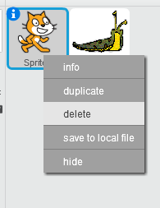
Next make sure that you are happy with the default name for the new sprite...
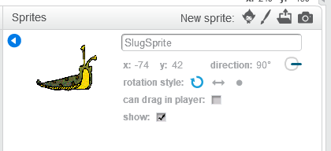
(I can live with that!)

Creating the Race Track
Please feel free to create your own race track in paint or similar, but a sample race track has been created for you (again on the module shell).
To import the track as the background for the stage import it via the stage editor...
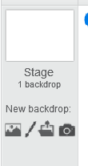

You should see something like this...


Adjusting the Slug Sprite
As things stand there is a big problem with the design, which is the slug is too big to easily navigate around the track. We need to make it smaller.
With the slug sprite selected select the “costumes” tab. This allows you to modify the slug graphic.
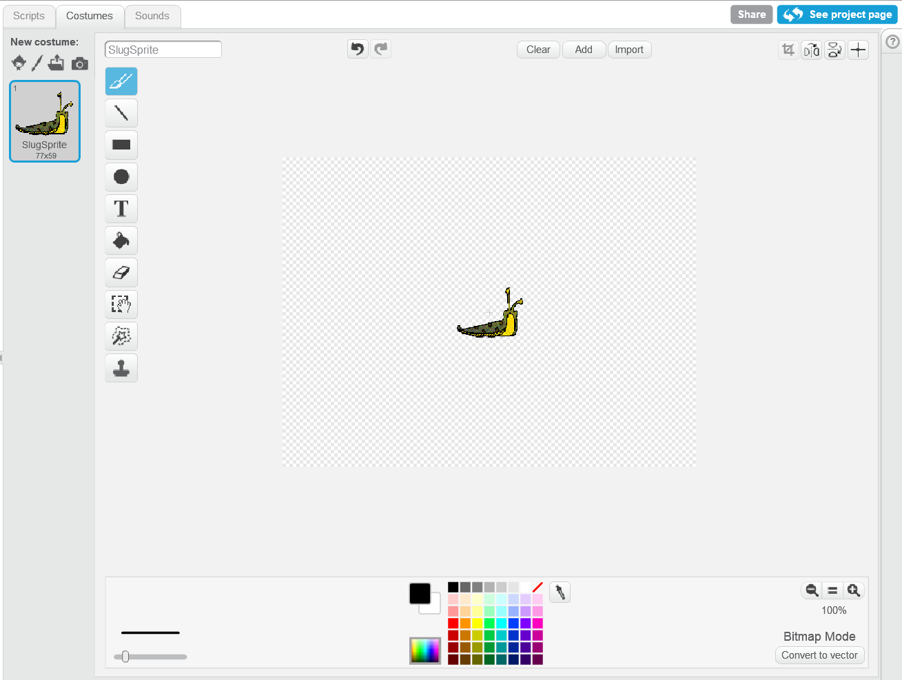
To adjust the size first click the select tool...

To make the slug smaller select the area around it with the left mouse button held down. You should see something like this...
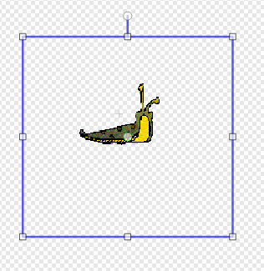
Resize the slug using the square handles indicated by the arrow above.
One thing to notice!
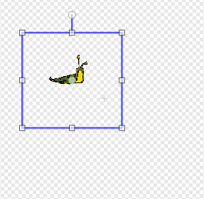
In the example here I have re-sized the slug but note the grey cross in the middle of the hatched area. This cross indicates the middle of the sprite. Notice that the slug has a circle indicated at the centre too.
This circle indicates the centre of the graphic.
Most of the time we want these two points to overlap otherwise the movement of the sprite can be unpredictable.
Arrange the two points so that they overlap like so...
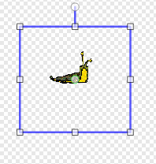
Once the alignment is OK click back on the scripts tab and the graphic on the stage should update based on the changes you have made...

What you are aiming for is to make the slug small enough to fit around the track giving the user a reasonable chance of not hitting the sides.

Adding the Green Flag
We are now in a position to start writing the script to make the game work. We shall start with adding an event to make the game start when the green flag is clicked...
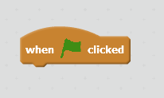

Adding the Forever Loop
As the name suggests a forever loop is one that goes on and on – forever!
Available from the control section drag it so that it connects with the green flag event like so...
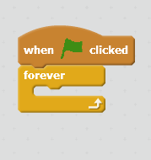
Notice the gap in the structure. This is where the majority of our commands will be inserted.

Point to Mouse
As the slug travels round the track, we want it to always point at the mouse pointer. To do this, simply add the motion command for point towards mouse like so...
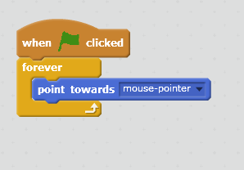
You might like to try testing the script to see what it does. Press the green flag and you should see that the sprite rotates depending on the position of the mouse.

Adding Motion
The next addition to the loop is to make the slug move. Again this is pretty simple with the addition of move n steps again under motion...
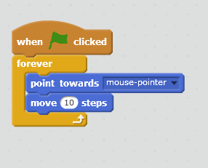
The default is 10 steps but to slow things down click on the number of steps and change it to a value of 1...
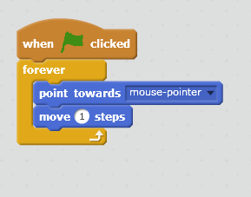
Again try out the script to see what it does. Not only should the sprite follow the mouse it should now move towards it.

Adding Collision Detection
As things stand nothing happens if the slug hits the side of the track. To add this feature we will need to make a decision along the lines of “if the slug hits the sides make a sound”.
Under the control section locate the if-then structure and add it to the script like so...
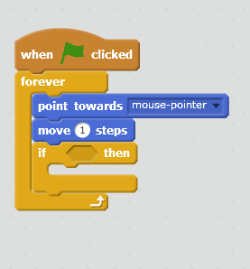
For the if-then structure to make its decision we need to add two features.
- A condition as to when the decision holds true
- An action to carry out once the decision is true
The condition is that the decision is true when the slug hits the edges of the track.
Under the sensing section there are number of instructions for sensing different conditions...
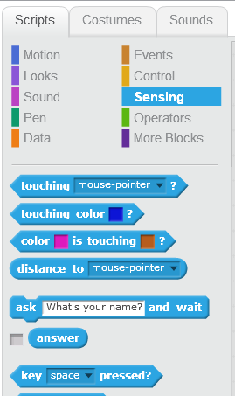
The one we are interested in is “touching color”.
Drag it to the if-then structure such that it docks like so...
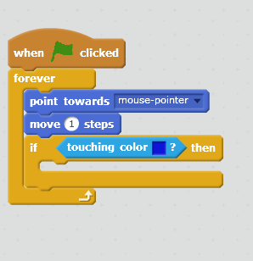
To set the colour we want to detect, click once on the blue square, then click once on the colour you want it to detect. It should now look like this...
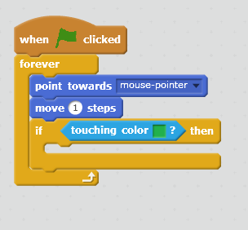
Having set the condition we now need to set the action.

Importing Sounds
If you flip over to the sound tab, you have the option of importing sound files to play when the slug crashes...
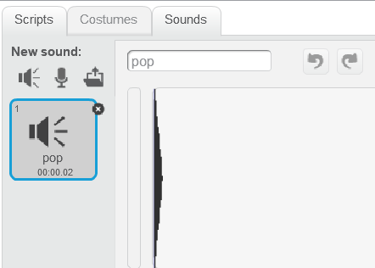
Save the sound file available on the module shell and import it into the project...
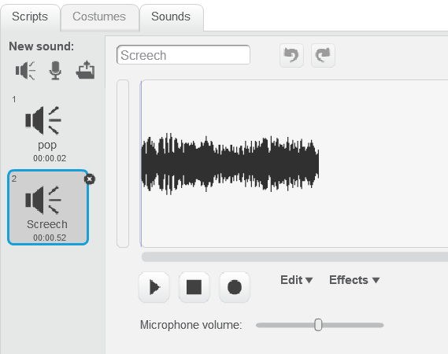
Flip back to the scripts tab and locate under sound, “play sound”. Modify the script like so...
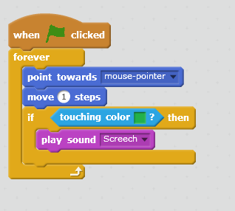
Try the game now, it should be nearly complete.

Adding the Slug Trail
One tool that allows us to draw lines as the sprite moves is the pen.
Under pen select pen-down and modify the script like so...
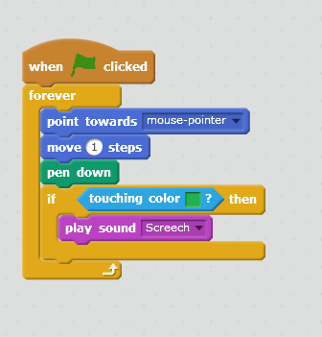
So here is a question. Is that the most efficient place to insert the instruction?
In writing code we may first have a go at something and then later realise that there is a more efficient way of doing things.
If with the pen it is either “up” or “down” does it make sense to keep putting the pen down all the way through the loop? When writing an algorithm it is a good idea to not add unnecessary commands where possible. It makes the code less efficient and potentially more confusing. Don’t get hung up either on code being perfect the first time either. This process of refining code is continuous and ongoing.
Take a look at the following script as a slightly more efficient approach...
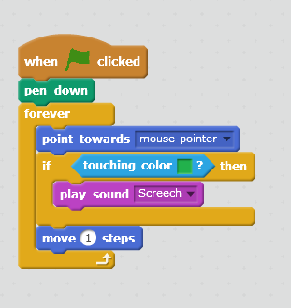
Lastly when we start a new run of the game it might be nice if the slug trail from the previous game was cleared.
The following modification will do this...
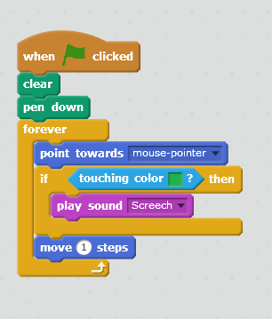

Extensions
Using the on-line sample game and asking the tutor try and see if you are able to record the number of crashes made by the slug during the course of the game. (Hint you will need to explore the section marked “data” and use a variable.)
The final game should look something like this...
